Customer Behavior Analysis
Varsha Patil¹, Akshara Sarode² ,
Nikita Chaudhari³ , Kaustubh Sonawane⁴, Samyak Badkul^{5,}

¹²³⁴⁵ Computer Engineering Department, SIES Graduate School of Technology, Mumbai, University of Mumbai, India

{varshap, aksharasce120, nikitacce120, kaustubhsce120, samyakbce120)@gst.sies.edu.in

ABSTRACT
This report outlines the implementation of various models, including Matrix Factorization and Time Series analysis, to develop a recommendation system using Amazon Fine Food Reviews data. We aimed to compare methods comprehensively, emphasizing the importance of considering a time factor to prevent recommending outdated products. Ultimately, we chose Matrix Factorization supplemented by Time Series as the optimal approach. Furthermore, we proposed a novel recommender system integrating stacked LSTM and an attention-based auto encoder, demonstrating superior accuracy, efficiency, and scalability. This approach effectively addresses the cold start problem in recommendation systems.

KEYWORDS
Recommendation system, Matrix Factorization, Time Series analysis, LSTM-based recommender.

INTRODUCTION
E-commerce platforms have revolutionized the way we shop, and user feedback in the form of product ratings plays a pivotal role in shaping consumer decisions. These ratings not only serve as valuable insights for potential buyers but also contribute significantly to the success of recommendation systems employed by these platforms. Understanding and analyzing these ratings have become essential in deciphering user needs and preferences, ultimately leading to more informed purchasing decisions. Our project, which focused on leveraging data from Amazon, aimed to develop and enhance a recommendation system capable of providing personalized suggestions to users. To achieve this, we implemented a variety of techniques including Matrix Factorization, Singular Value Decomposition (SVD), Deep Learning, Random Forest, and Time Series analysis. By comparing and combining these methods, we sought to refine the accuracy and effectiveness of our recommendation system.

The significance of our project extends beyond the realm of e-commerce for several reasons. From a business perspective, the ability to accurately recommend products can have profound implications. Firstly, it can lead to increased revenue by identifying potential demand and facilitating more targeted marketing efforts. Secondly, a well-functioning recommendation system can enhance client retention, as satisfied customers are more likely to return for future purchases, thus fostering long-term relationships.
In the broader context, recommender systems play a pivotal role in addressing the challenge of information overload by providing users with personalized recommendations tailored to their preferences and interests. Despite the potential benefits, existing approaches to recommendation systems are not without their limitations. Our research aims to address these challenges head-on by developing more robust and scalable recommendation algorithms capable of handling diverse datasets effectively.

In summary, our project represents a concerted effort to not only improve recommendation systems but also to deepen our understanding of the underlying principles governing user behavior and preferences. By exploring novel methodologies and algorithms, we hope to pave the way for more effective and ethical recommendation systems that empower users and drive business success in the digital age.

- PROBLEM DEFINITION
The problem we are going to solve is how to help users select products which they may like and to make recommendation to stimulate sales and increase profits.
Firstly, we decided to choose the Amazon Fine Food Reviews dataset which consists of 568,454 food reviews Amazon users left up to October 2012 as our dataset.
Secondly, our recommendation system is based on users rating prediction. We assume that users tend to like the products that have a score of greater than 4 and we will consider the highest 5 scores product as our recommendation candidates.
Thirdly, we implemented several algorithms to predict the scores of each product for each user.

2.1 Distance Based Model
Here we use the cosine-distance to give the similarity between vectors. Cosine similarity is a measure of similarity between two non-zero vectors of an inner product space that measures the cosine of the angle between them. The similarity ranges from -1 to 1 where
-1 means exactly opposite, 1 means exactly the same and in- between values indicating intermediate similarity or dissimilarity.
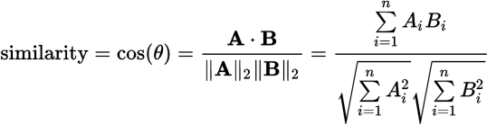

Since the MSE of traditional Collaborative Filtering model is quite high, we decided to use quasi-SVD approach instead. In this method, the output matrix is the dot product of three matrix. Here U is user similarity matrix and P is product similarity.

  - Matrix Factorization
Matrix Factorization is another way to decompose the user-product matrix. MF models map both users and products to a joint latent factor space of dimensionality f (f refers to the number of the latent factors), such that user-product interactions are modeled as inner products in that space. In this report, we create two new matrices “user-latent_factor” (size q*f, q refers to number of users) and “product-latent_factor” (size p*f, p refers to the number of
products). Element in target matrix can be calculated as
We choose Least-square method to minimize the loss. Constant λ
controls the extent of regularization.

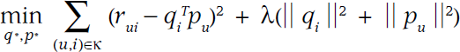

  - Random Forest
Random forests or random decision forests are an ensemble learning method for classification, regression and other tasks, that operate by constructing a multitude of decision trees at training time and outputting the class that is the mode of the classes (classification) or mean prediction (regression) of the individual trees.
This process is sometimes called "feature bagging". These are models built from a training set for new points x' by looking at the "neighborhood" of the point, formalized by a weight function W:

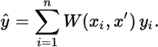
Since a forest averages the predictions of a set of m trees with individual weight functions Wj, its predictions are

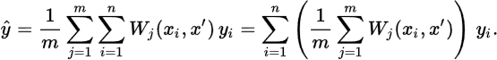
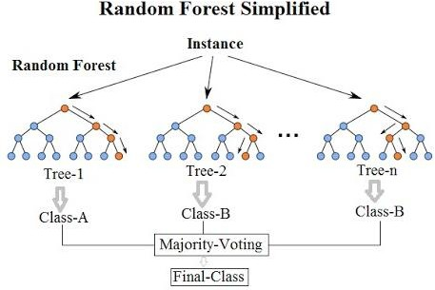
One of the advantages of random forests method is that it can avoid overfitting because of the law of large numbers.

  - Probabilistic Matrix Factorization
In PMF, we assume that the appearance of user and product are compiled to Gaussian distribution as following.5

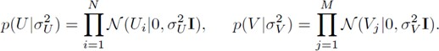
The distribution of Scores is the joint distribution of the former two variables.

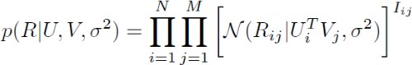
According to Bayesian formula, we can get the final objective function as following:

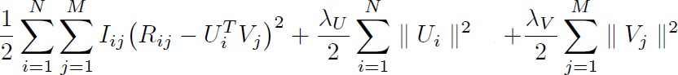

2.5 SVD
We apply Singular value decomposition (SVD) algorithms to mapping the user-product matrix into low-dimensional space.

Then we can get the predicted scores based on the similarity between unscored items and the others.
As for evaluation, we choose MSE (including train set and test set MSE) and Confusion Matrix (score >4 as recommend, score <4 as not recommend) to evaluate all the models above.
Additionally, we introduce a time parameter with vote to the final model. Which means if the score predicted by the time parameter is below 3, we will not recommend it in the end.

- RELATED WORK
Our project relied on this paper “Matrix Factorization Techniques for Recommender Systems” [5] as the theoretical framework. We found out that matrix factorization models are superior to classic nearest-neighbor techniques for producing product recommendations and this is also proved by our research. Recommender systems are based on one of the two strategies: Content filtering and Collaborative filtering.

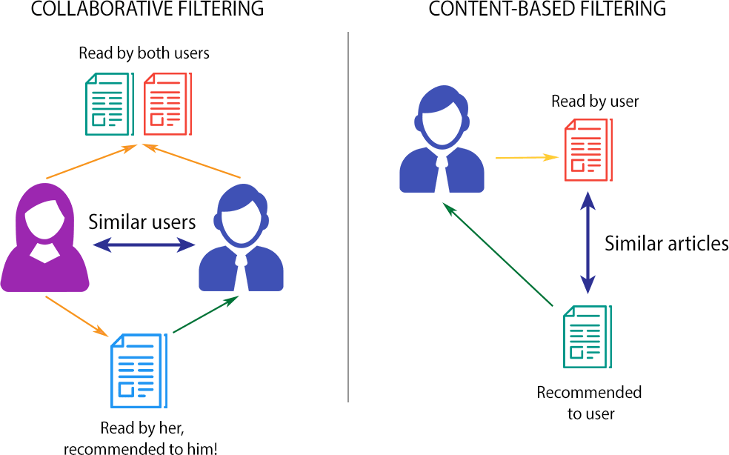
Fig 1 Content vs Collaborative Filtering

Content filtering
This approach creates a profile for each user or product to characterize its nature. For example, a movie profile could include attributes regarding its genre, the participating actors, its box office popularity, etc. The profiles allow programs to associate users to products. The paper mentioned that a known successful realization of content filtering is the Music Genome Project, which is used for the internet radio service Pandora.com. A trained music analyst scores each song in the Music Genome Project based on hundreds of distinct musical characteristics. These attributes will contribute to recommend listeners’ songs. However, based on the Amazon Fine Food Database, we don’t have the profile information on products nor on users. Thus, we will focus on the second method.

Collaborative Filtering
The other algorithm relies on past user behavior – for example, previous transactions or product ratings – without requiring the creation of explicit profiles. This is more suitable for our project. Collaborative filtering analyzes the relationships between users and interdependencies among products to identify new user-item associations.
The two primary areas of collaborative filtering are the neighborhood methods and latent factor models. Neighborhood methods are centered on computing and relationships between items or, alternatively, between users. This method can be categorized into two genres: user-oriented neighborhood method and product-oriented neighborhood method.
User-oriented neighborhood method: Joe likes the three movies A, B, and C. To make a prediction for him, the system finds some similar users who also like those movies, and then determines which other movies they liked.
Item-oriented collaborative filtering: this in essence just chain recommendations off a particular item. The main advantage is that it can recommend items to users who we know nothing about except for what item they may be looking at currently.

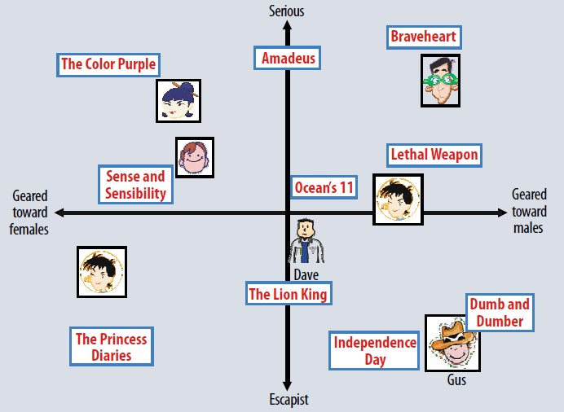

Fig 2 Latent Factor Approach
For our amazon fine food case, the discovered factors might measure obvious dimensions such as soft drinks, alcohol and food but also less well-defined dimensions such as how tasty is a food; or completely uninterpretable dimensions. For users, each factor measures how much the user likes foods that score high on a certain type. Figure 2 (also from the paper) illustrates the idea for a simplified example in two dimensions.

Matrix Factorization Methods
Some of the most successful realizations of latent factor models are based on matrix factorization. In its basic form, the matrix factorization characterizes both items and users by vectors of factors inferred from the rating patterns. We will discuss more about the Matrix Factorization Model in Part 4 Methodology.

Comments and Improvement
As we mentioned in 3.1, we referred to “Matrix Factorization Techniques for Recommender Systems” [5] as our theoretical framework. We would like to verify if Collaborative Filtering based on Matrix Factorization methods is the state-of-art method for recommendation systems. Besides, we believe that it is not appropriate to omit the time factor. Whether a product is outdated is a key factor for a client to decide to purchase or not.

METHODOLOGY

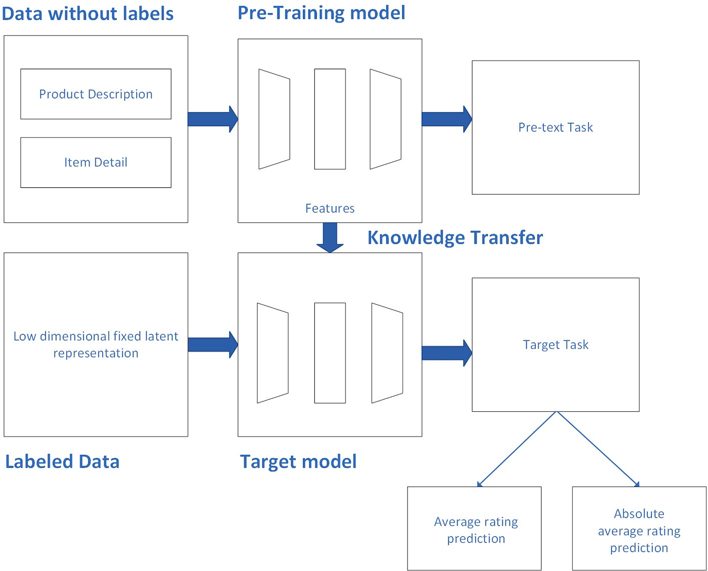

Figure : Methodology of proposed technique
  - Dataset and Pre-processing
As Fig 1 shows, our datasets have a Data frame size of 568454 * 10.
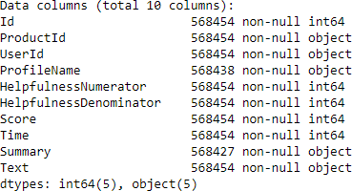Figure 3: Data Frame size

In Fig 2, we show that almost all users bought less than 60 times and almost all products have been purchased less than 200 times.
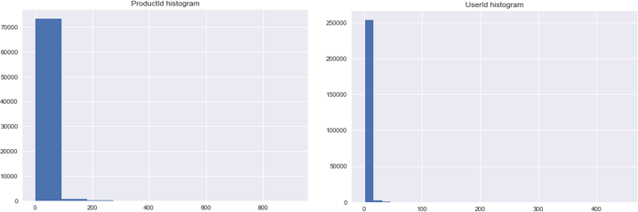

Figure 4: Histogram of ProductId and UserId
To reduce computation complexity, we filtered all items with less than 10 counts in ProductId and 10 counts in UserId.
Besides, we created two new columns #Users, #Products to capture how many times the user/product appeared in the database.
Finally, we believe that it’s unlikely for us to get additional information from “text” information (it’s impossible to predict one’s preference only base on their text comments on different products), we decided to drop “Summary” and “Text” columns. After feature engineering, our data consist of 64.3k rows and 5 columns (ProductId, UserId, Score, #Products, #Users)

  - Algorithms
    - Distance Based Model
In this part, we use the cosine-distance based model, and it is a little different from the traditional collaborative filtering. The traditional CF use either user similarity matrix or product similarity matrix to predict the whole user-product matrix. However, we found it was not applicable in this data set -- the MSE is way bigger than other methods. Then we tried to use a quasi-SVD approach. That is, the output matrix is the dot product of three matrix:
U is user similarity matrix and P is product similarity. And we use this algorithm to update the target matrix, the user-product matrix. Our train set MSE is 2.0860 and our test set MSE is 2.1480.
The advantage is that this method is quite interpretable. However, the drawbacks are also apparent: this algorithm is naive with a deficient performance. For a large data set, this algorithm needs m²+n² times to calculate the similarity matrix.
    - Matrix Factorization

Latent factor models are an alternative approach that tries to explain the ratings by characterizing both items and users on, say, 20 to 100 factors inferred from the ratings patterns. For products, the discovered factors might measure obvious dimensions such as candy vs drinks, or adult food vs children’s; For users, each factor measures how much the user likes the product that score high on the corresponding movie factor.
Using latent factor model, we transform the way to calculate the similarity of users and products. The features become more stable and condense.
we first create two new metrics, user-latent_factor and product- latent_factor. The size are q*f and p*f, p, q are the total number of users and products, f is the number of latent factors. So, every
element in the target matrix can be calculate as:
And the target matrix is shown as . Next, we need to create the objective function based on least-square method to minimize the loss:

The system adjusts the model by fitting the previously observed ratings. However, the goal is to generalize those previous ratings in a way that predicts the unknown ratings. Thus, the system should avoid overfitting the observed data by regularizing the learned parameters by adding L2 term. The constant λ controls the extent of regularization and is usually determined by cross-validation.
Next, we use stochastic gradient descent to optimize the objective function. The processing is:
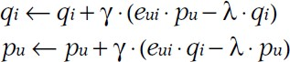
Where gamma is the stochastic learning rate and e is the error term. In the iteration, when the change in loss is larger than 0, the learning rate increases by 5%; if delta-loss is smaller than 0, it means the new loss is becoming larger. The learning rate decreases by 50% so that the loss can converge.
The MF gives a very good prediction: the train set MSE is 0.03542 and the test set MSE is 0.03385. While both MSEs are equally small, thus no overfitting problem occurs.
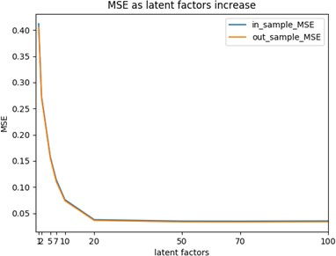
In addition, as Fig 3 shows that the number of latent factors significantly affects the results.

Figure 5: Latent factors and MSE

As the number of latent factors increase, the MSE decreases. And MSE converges around n=20.
    - Probabilistic Matrix Factorization
PMF is similar to MF. It is nothing more than a MF assuming the distribution of user and production are Gaussian. That is:

And the joint distribution of user and product is the distribution of the scores.
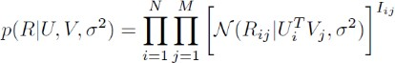
The problem comes to maximum the probability of U, V based on R and variance. This transformation is based on Bayesian formula. Rewrite the function above and applying log to both sides:

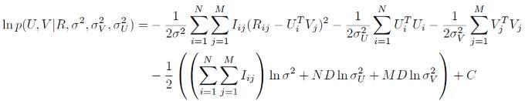
When optimizing this function, the standard errors are fixed, so the objective function is:

Gradient descent process is the same with basic MF.
PMF does better than MF for sparse matrices. The assumption of Gaussian makes it more accurate to predict. But for our dataset, the chosen data is not sparse, so the performance of PMF is almost the same with MF. the in sample MSE is 0.036697 and the out sample MSE is 0.030156.
    - SVD
In our recommendation system, we have such a matrix which has many scores from the users to the items. We hope to predict the targeted users’ score to other unevaluated items and then recommend the items with the highest five scores.
The advantage of SVD is that: users’ score matrix is a sparse matrix, so we can map the original data into a Low-dimensional space and then calculate the similarity of different items. This can help us reduce calculation complexity.

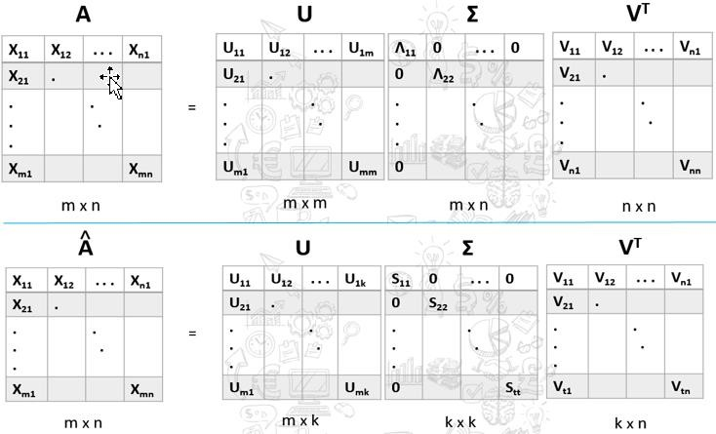
Figure 6 : Time Series

After our exploratory data analysis, we found out that the ratings are related to the time: the latter, the better.

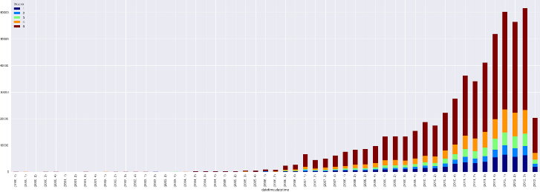

Figure 6: Score distribution based on Time
Besides, the popularity of a product is naturally linked to different time periods. iPhone 4 was a 4.8/5 product in 2010 but it will be inappropriate to recommend the same product in 2013.
We decided to convert different ProductId and UserId into dummy variables, and ran RandomForestRegressor on ProductId, UserId and Time. We consider time series forecasting score as a threshold: if it is below 3, we will drop the candidate.
    - Text Mining
As Fig 7 indicates, Text column is essential for sentimental analysis
To better complement our recommendation, we also use Natural Language Process methods to find 5 key words for each product.

Firstly, we group comments of each product and then tokenize them. Then, we counter the most frequent five words and drop the stopwords. (refer to 4.2.5 for a demo)

    - Recommendation

After comparing different methods, we decided to use Matrix Factorization as our basic algorithm to predict for a certain product for a certain customer. We select the top 5 scores as our recommendation candidates. Then we introduced the time series method to determine if the score is below 3 or not. If yes, we will drop this candidate. Otherwise, we keep the original five.
Demo: we randomly pick a UserId and ran our recommendation system.

Our recommender framework learns in a self-supervised manner which can be seen as a representation learning method that consists of two tasks, mainstream task in the pre-training stage and downstream task where our system learns to make predictions/recommendations via fine-tuning the representations with few labels. The underlying model in the fine-tuning stage accepts compressed and fixed latent features generated from the pre-training stage. Another important significance of the downstream task is to assess the suitability of learned features for different intra-domain tasks. We focused on two intra-domain tasks, predicting the average rating of items, treating the problem as a regression one and predicting the absolute average rating, treating the problem as a classification one. With this context, Fig. 1 provides an overview of our methodology.
Considering all other factors, including scalability, efficiency, accuracy, and generalization ability, our suggested technique consistently delivered the greatest performance. This section comprises four sub- sections.

    - Learning from pseudo signals
This section combined two pseudo signals as a single pre-text task during the pre-training stage. The one pseudo label is the product’s title, while the other signal comes from the masked words of the product description, which act as the input to the model, as shown in Fig. 2. The model will fill in the masked words and predict the product’s title. We leverage correlations, naturally available metadata embedded in the data, and domain knowledge to construct the pre-text task. The training process during the mainstream task leverages these supervisory signals because these are embedded as naturally available information with the products. Our approach handles the Systemic bootstrapping problem, common in product recommendation systems. Systemic bootstrapping refers to the very initial stage of the system when the recommender has no information to work with. This example shows the shortcomings of the minimal interaction and the new items situations because all assets and users are brand new.
As a result, many existing methods need help handling system bootstrapping. How our system handles the situation is very simple. Our model leverages the bare minimum information that comes naturally with each item and product, whether old or with little to no interactions. The bare minimum information refers to the product description and title, as shown in Fig. 2.
Every single product on any e-commerce portal has a description that aims to supply customers with important information about the features and the benefits of the product so they are compiled to buy. Similarly, every product has its title to eliminate ambiguity and help customers create a mental image of its use and presence. This bare minimum in- formation is utilized during the pre-training stage of the model.
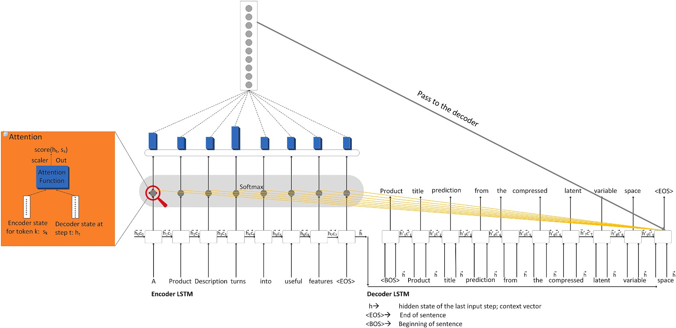
Fig Schematic structure of Stacked LSTM attention-based autoencoder.

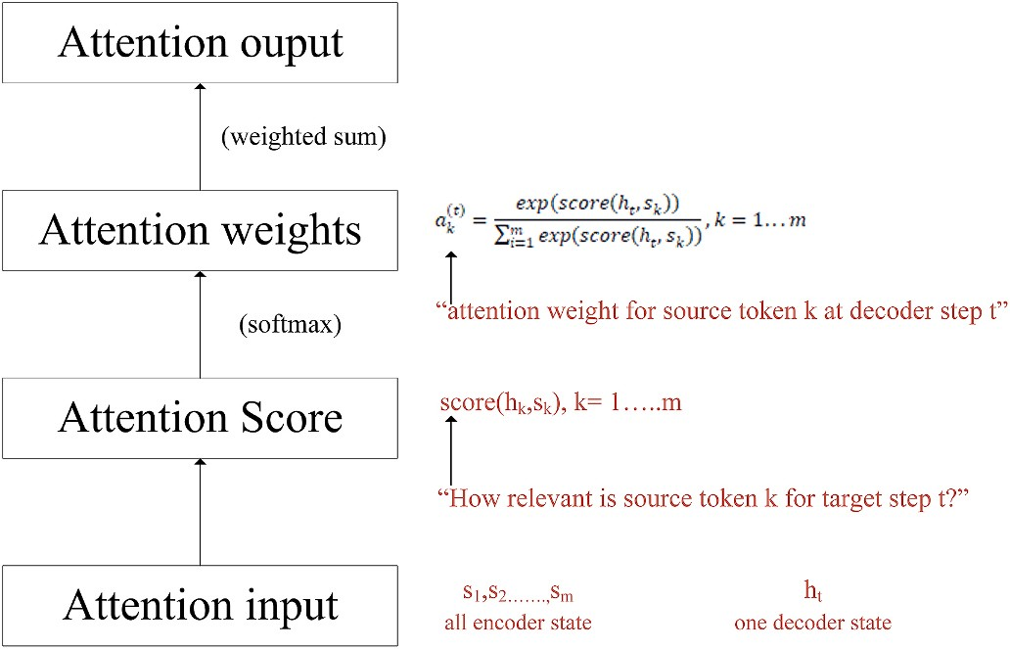

Fig Differentiable Generalized calculation method attention architecture.

    - Stacked LSTM attention-based autoencoder

This section explains the working mechanism of the stacked LSTM
[23] modules in both the encoder and decoder using the product’s title prediction from its masked description. We leveraged glove vectors trained on the Wikipedia and Giga Word datasets and fine-tuned them during training. This enabled the neural network to learn effectively and reach convergence quickly. The encoder in the models we’ve looked at condensed the entire source sentence into a single vector.
Due to the number of different possible meanings of the source sentence, this might be pretty challenging. The encoder is likely to overlook some crucial information when pushed to encode all the data into a single vector. The decoder finds it challenging as well. The decoder only sees one source representation, but at each generational stage, some elements of the source might be more useful than others. The structure of the stacked LSTM attention-based autoencoder is shown in Fig. 3 [23]. An attention mechanism determines which parts of the source are more useful at each decoder phase. In this configuration, the encoder does not need to vectorize the entire source into a single file. At each step of decoder attention, the following steps are performed, and the computation scheme is shown in Fig. 4.
Step 1 Receive three inputs (i) attention input, (ii) a decoder state h_{t,} and (iii) all encoder states, s₁,s₂,s₃ … s_{m}.
Step 2 Compute attention scores. For each encoder state s_{k}, attention calculates its “relevance” for this decoder state h_{t} followed by applying an attention function It gets a score as a scalar value along with a decoder state and an encoder state.(h_{t},s_{k})
Step 3 Attention output is computed as the weighted sum of encoder states with attention weights.
Step 4 Compute attention output, the weighted sum of encoder states with attention weights.

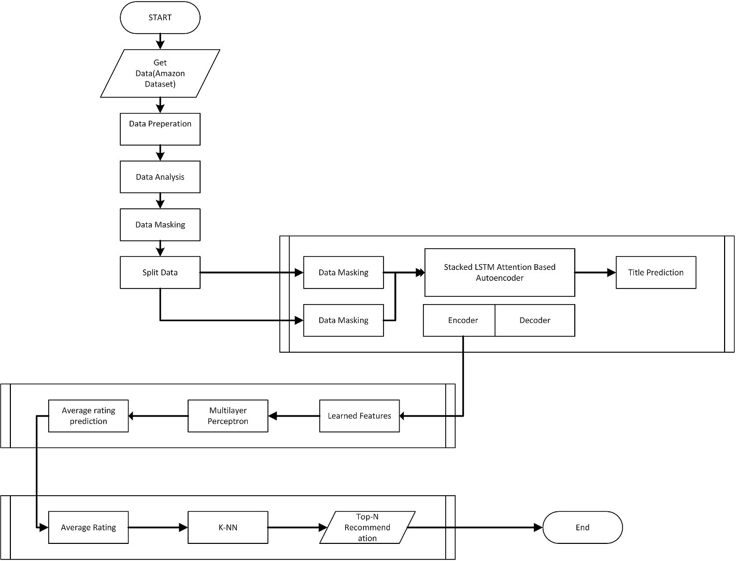

Figure End to end flowchart of proposed model

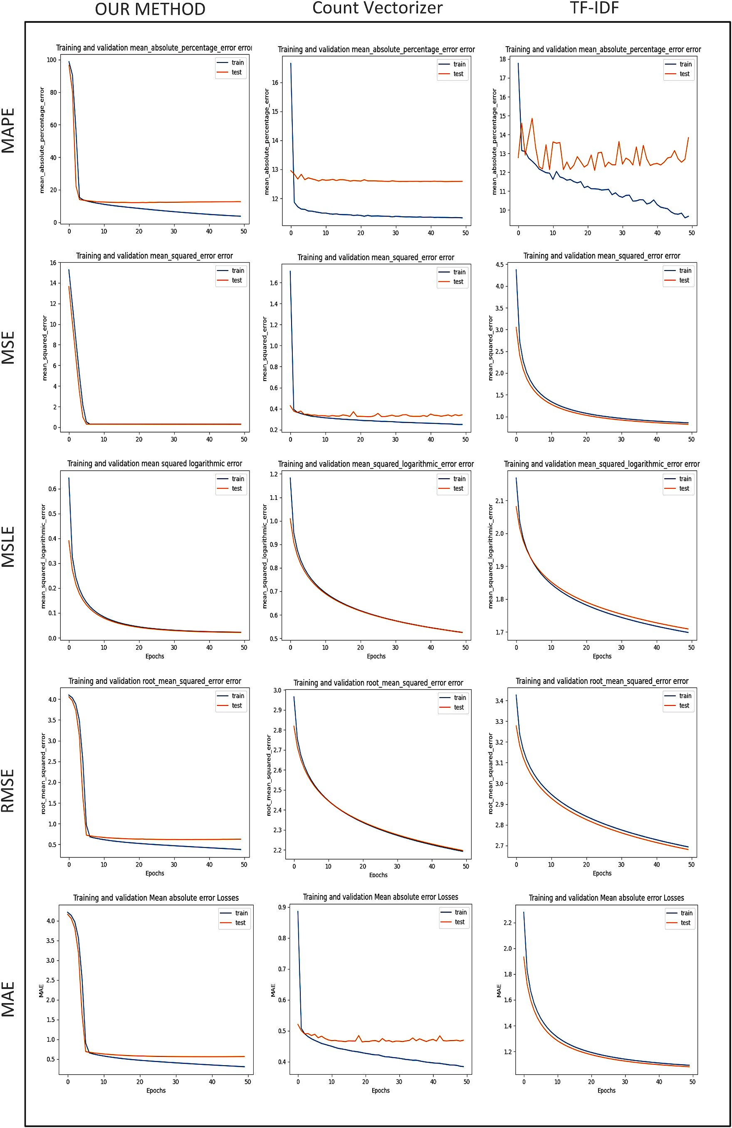

Figure Performance comparison graphs on Prediction Metrics.

5. Limitations

The few limitations are of the study are as follows.

    - Interpretability
Despite its effectiveness, it is well-known that deep learning behaves like black boxes, and that providing explainable predictions looks to be exceedingly challenging. Their non-interpretable weights and activa- tions limit their ability to explain.

    - Limited feature representation
We leveraged the bare minimum information, which restricts the feature representation capability of the model. Throwing various other ITEM and USER metadata information is a severe bottleneck. The model would have learned more complex and valuable features if it had also been provided with different embeddings.

    - Heterogeneous content information
To accommodate diverse information such as text, graphics, audio, and video. In the field of multimedia, deep learning networks have achieved significant advancements. Data processing and demonstrated potential in multiple source representations learning. But our model has yet to be exposed to such heterogeneous information from different sources.
    - Extensive hyperparameter tuning
The requirement for substantial hyperparameter adjustment is the third argument against models based on deep learning. The requirement for substantial hyperparameter adjustment is the third argument against models based on deep learning.

RESULT

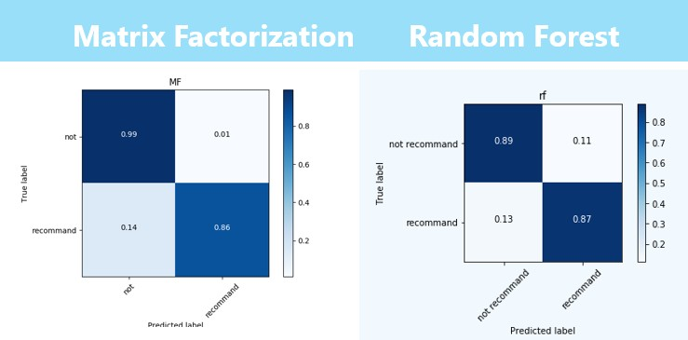

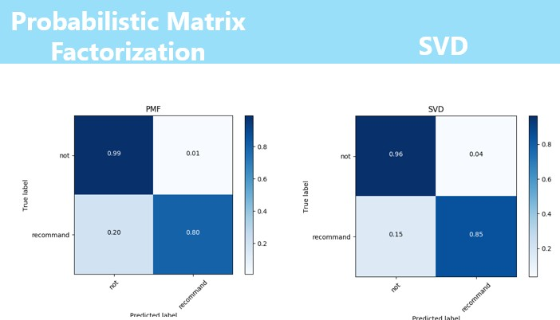

Figure 8: Confusion Matrix
Here we define articles of score > 4 as our recommendation candidates.

CONCLUSION
Since Matrix Factorization algorithm performed best in all the score predicting methods, we decided to use Matrix Factorization to fill all the empty cells and predict the scores for each user. We then choose the highest 5 products as our candidates. Finally, we take the time parameter into account. If the score from time prediction is below 3, we reject this candidate and choose the 6th one.
Considering the future work, we have found some limitation as follows:
- We only extracted UserId, ProductId, Scores and Time from the original database but didn’t analyze the textual information. More research on sentimental analysis for the textual data may be needed. Besides, the HelpfulnessNumerator and HelpfulnessDenominator may also help us determine who are the influencer and which information is considered as influential review by our users.
- We assumed that if the product score is higher than 4, the user will like the product. The evaluation part can only assess the performance of rating prediction. But how to predict if users are more likely to buy these products remain uncertain. For example, two items A and B are very similar, but A is more expensive. A can’t be afforded by the user even if he bought B before and rated
5. Here, high score doesn’t mean more likely to be purchased.
3. To make the system perform better, we tried to include time as a factor. Although a product gets high score, we still need to consider the time feature. We believe that there are more features to be considered as well. For example, the product viewed history, the income of the user and so on. If we take more factors into account, our recommendation system should perform better.

In this paper, a method is described for product recommendation which learns to recommend the items in three different stages. In the first stage, models learn the underlying explanatory factors and good representations from naturally available abundant information. In The second stage, knowledge transfer happens, and the downstream model gets restrained. And lastly, in the third stage, the actual recommendation is performed. Then the proposed method is compared with two base- lines, TF-IDF and Count Vectorized-based item-based RS. The proposed approach consistently provided the best performance considering all other aspects, such as scalability, efficiency, accuracy, and generaliza- tion capability. Existing studies have established a good framework for recommender system research, but this section also outlines a number of promising future research directions. A few unresolved issues that are essential to the current state of the field are also elaborated.

REFERENCES

- J. McAuley and J. Leskovec. From amateurs to connoisseurs: modeling the evolution of user expertise through online reviews. WWW, 2013. The link: https://www.kaggle.com/snap/amazon-fine-food-reviews/data
- Salakhutdinov and Mnih, Probabilistic Matrix Factorization, NIPS 2008.The link: http://papers.nips.cc/paper/3208-probabilistic-matrix- factorization.pdf
- Mohammad Khoshneshin, Collaborative Filtering via Euclidean Embedding, RecSys '10 Proceedings of the fourth ACM conference on Recommender systems.The link: http://citeseerx.ist.psu.edu/viewdoc/download?doi=10.1.1.308.7304&rep=r ep1&type=pdf
- Zhang et al., Collaborative User Network Embedding for Social Recommender Systems, Proceedings of the 2017 SIAM International Conference on Data Mining. The link: http://repository.kaust.edu.sa/kaust/bitstream/10754/625053/1/1.97816119 74973.43.pdf
- Koren, Yehuda, Robert Bell, and Chris Volinsky. "Matrix factorization techniques for recommender systems." Computer 42.8 (2009).

- Javed, N. Majeed, S. Ishtiaq, N. Majeed, M. Maqsood, A. Javed, Improved scalable recommender system the nucleus improved scalable recommender system, in: The Nucleus, 2016 (Vol. 53, Issue 3), www.thenucleuspak.org.pk.

- Pujahari, D.S. Sisodia, Item feature refinement using matrix factorization and boosted learning based user profile generation for content-based recommender systems, Expert Syst. Appl. 206 (2022) 117849, https://doi.org/10.1016/J. ESWA.2022.117849.

- Wendland, M. Zenere, J. Niemann, Introduction to text classification: impact of stemming and comparing TF-IDF and count vectorization as feature extraction technique, Communications in Computer and Information Science 1442 (2021) 289–300, https://doi.org/10.1007/978-3-030-85521-5_19/COVER.

- W.X. Zhao, S. Li, Y. He, E.Y. Chang, J.R. Wen, X. Li, Connecting social media to E- commerce: cold-start product recommendation using microblogging information, IEEE Trans. Knowl. Data Eng. 28 (5) (2016) 1147–1159, https://doi.org/10.1109/ TKDE.2015.2508816.

